Chek

Room

Check

Roomno = int

CheckIn = datetime

CheckOut = datetime

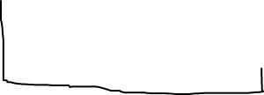

Hotel

addRoom(roomno)

getListOfRooms()

getIndex()

vhotel = hotel name

ListOfRooms = []

revenue = 0

getdoubletotal()

getsingletotal()

getdoublefee()

getsinglefee()

Double bed room total = 0

Single bed room total = 0

Double bed fee = 1000000

Single bed fee = 500000

Calculatetimestayed()